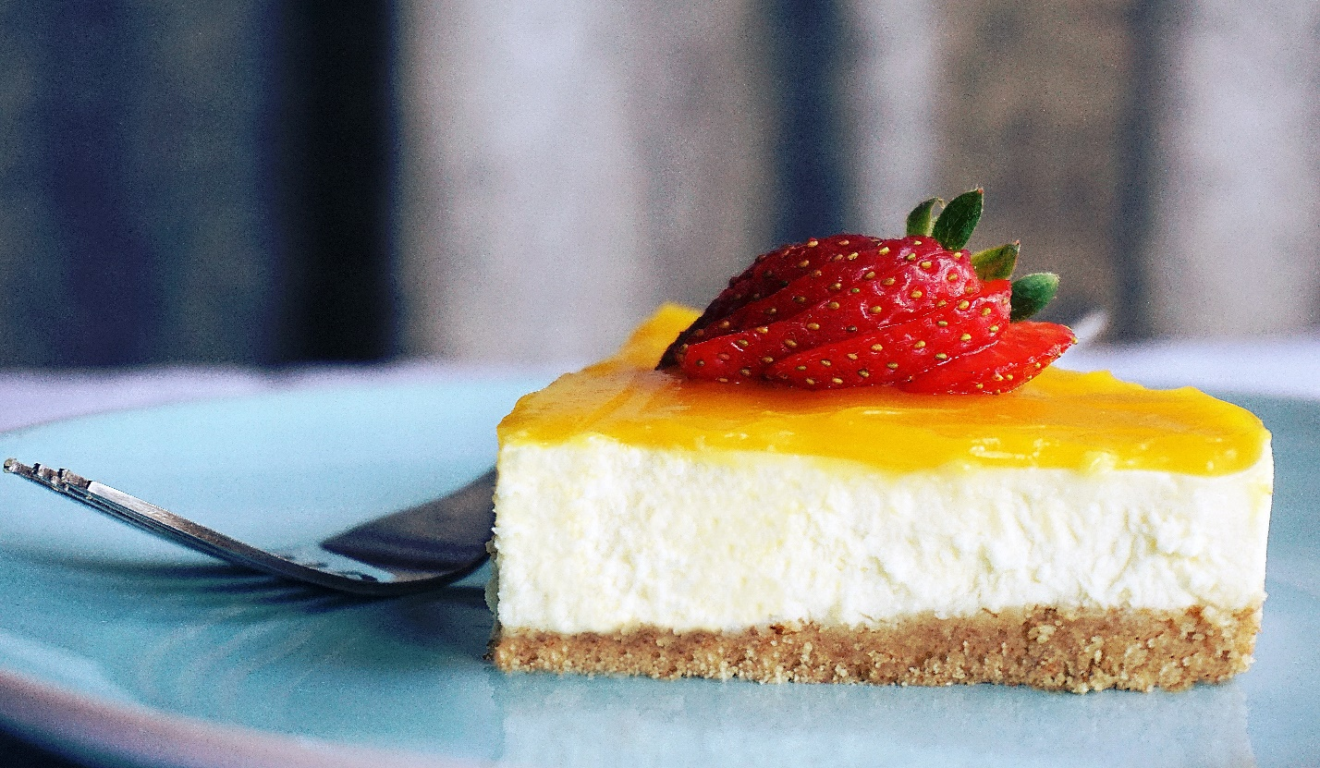

**Thank you for choosing The Cake**

These terms and conditions serve as the contract between the customer and The Cake. By paying this invoice, the customer is agreeing to the these terms and conditions.  
Terms and conditions are subject to change without notice.

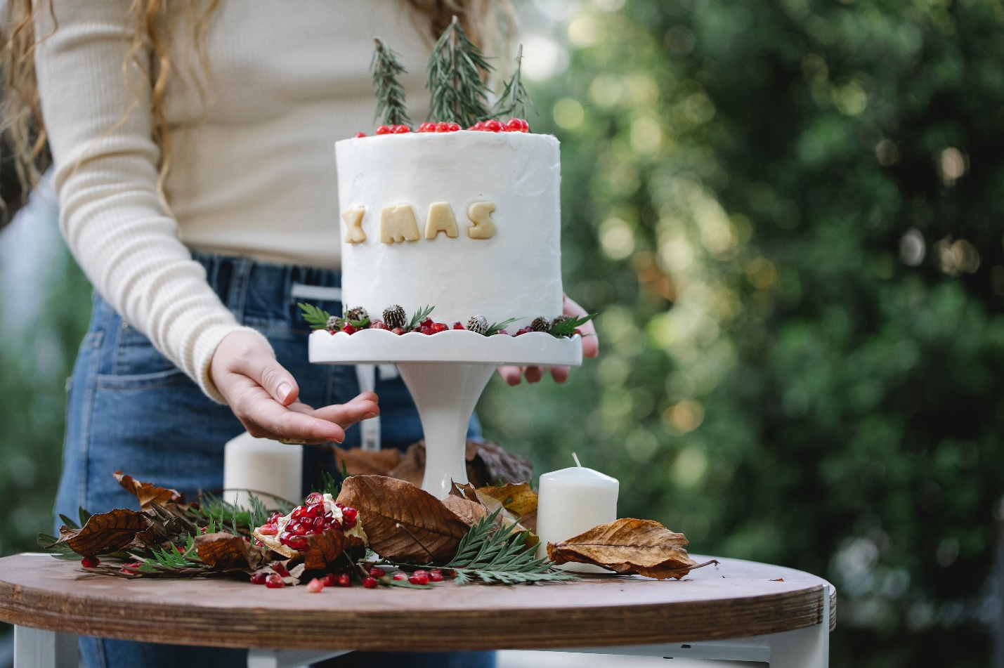

Delivery.

Orders for postal delivery are currently despatched on Tuesday, Wednesday and Thursday each week.  Orders must be received by 12pm the day prior to delivery in order to leave time for freshly baking your items. Some items may require a longer turn-around (eg. Sourdough loaves which must be ordered by 8am the day prior to despatch, All our perishable products are sent to you fresh and securely packed to arrive the following day - as such we are able to deliver only to Zones A and B.

* Your order will be arrive any time between 9am and 5.30pm on your delivery day.
* Delivery is not guaranteed for any particular time during the day.
* Please let us know as soon as possible if your order has not arrived within the time frame.

Please note that delivery dates may be affected by public or Bank holidays.

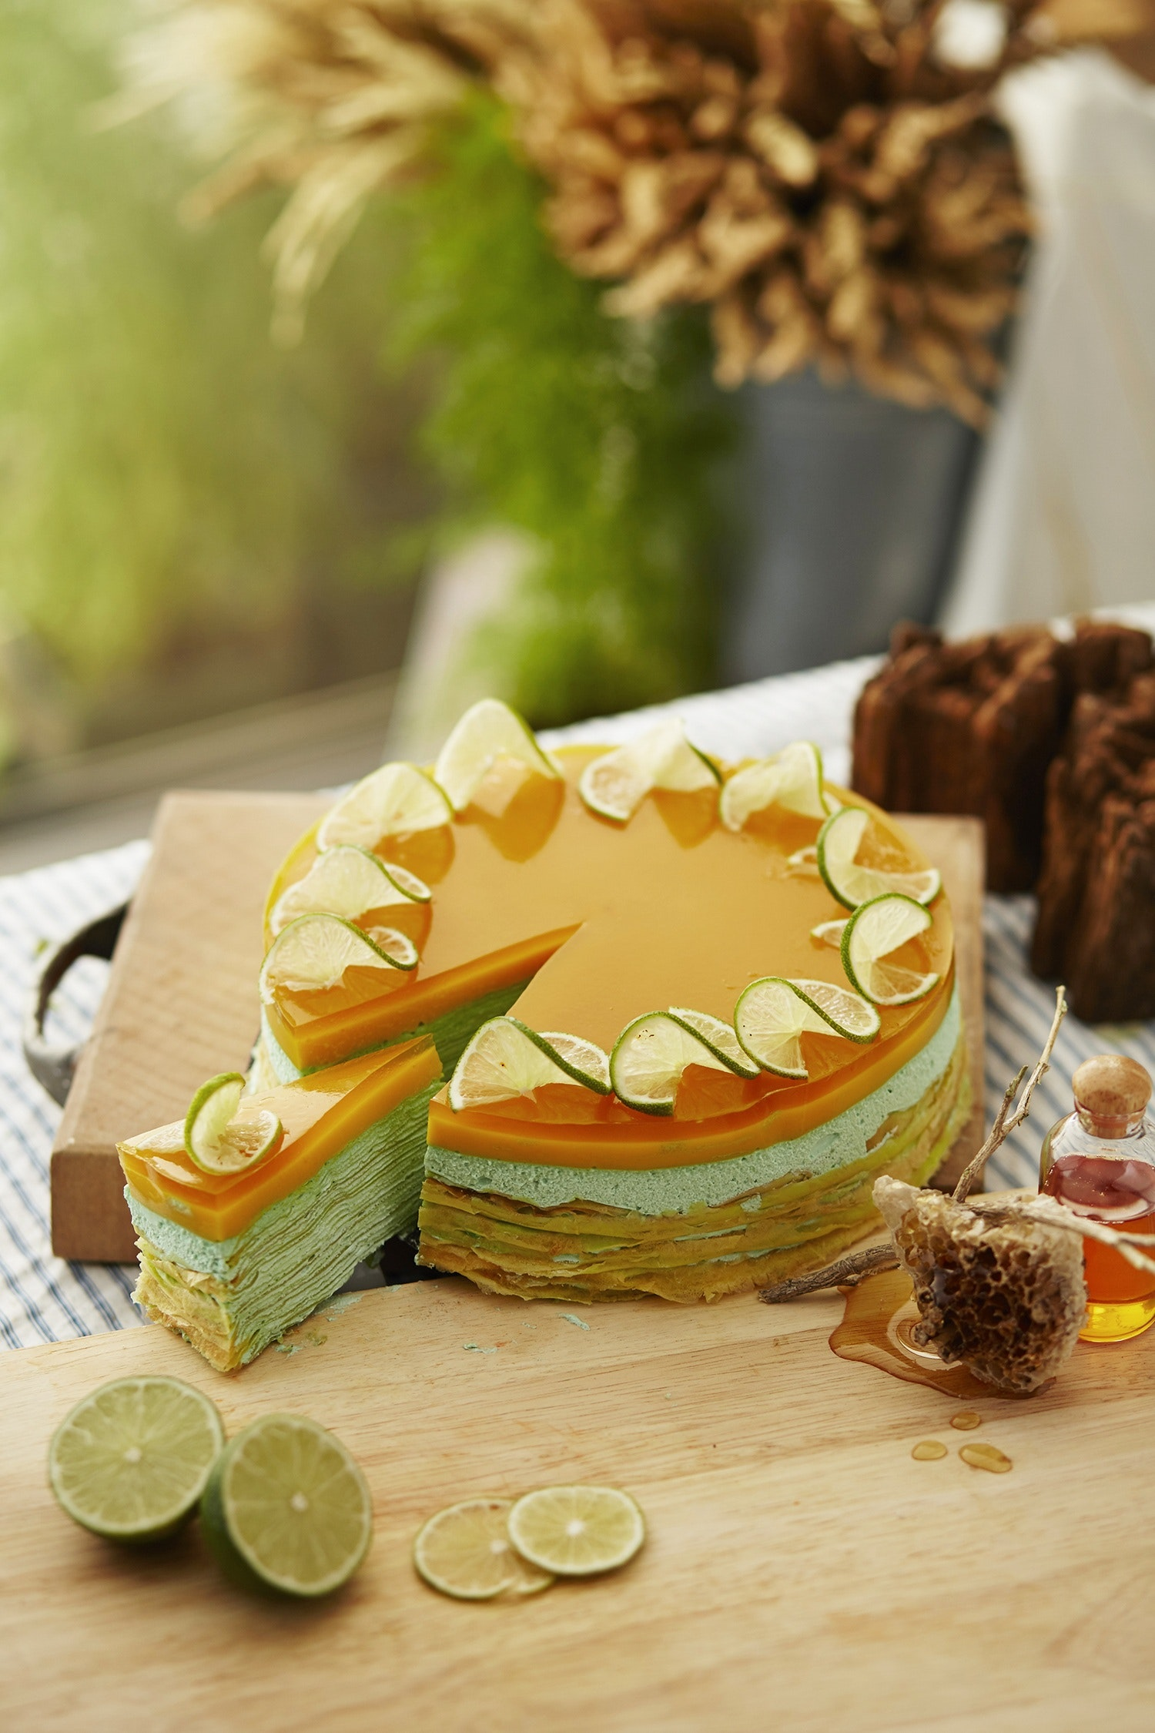

**PAYMENTS**

All sales are final.  
All payments are non-refundable. Store credit can only be issued by The Cake Management. Any refund or store credit requests must be submitted in writing via email to info@thecake.com. The Cake has 14 days to review this request and determine an outcome. The outcome will be sent the email address of the requester.  
The initial deposit reserves your event date, is non-refundable and non-transferable. Its monetary value cannot be applied to store credit or a later dates.  When we take your event order, we begin the process of declining other orders. As we get closer and closer to your event date, the chances of re-booking your date are greatly reduced.  
The balance must be received within the following time frames below. Reservation deposits should be received within 72 hours of invoice receipt. Final payments are due on the date specified in the invoice. A 15% late fee will be charged each day the final payment is late. 

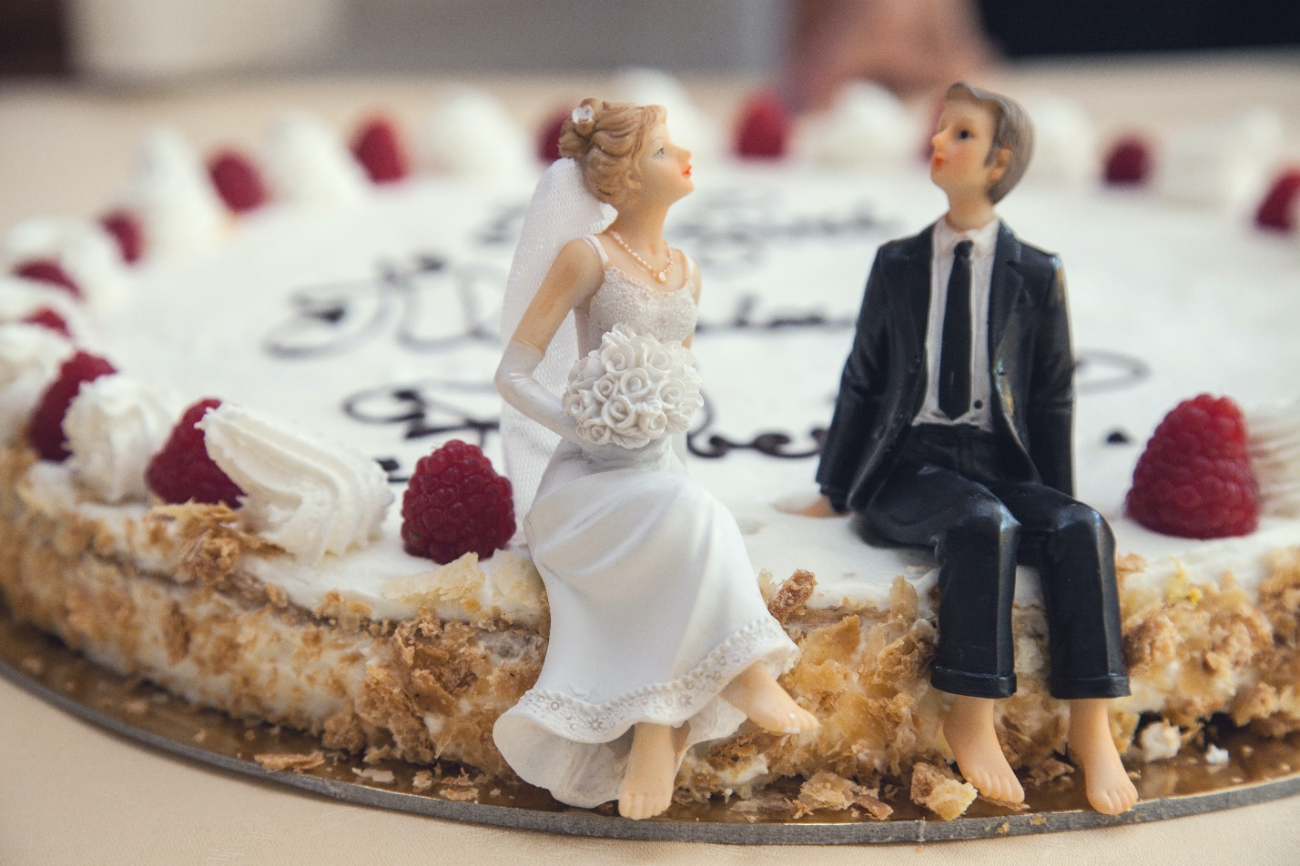  
**WEDDING ORDERS (wedding, grooms)**  
When ordering 14 days or more in advance, a 50% non­-transferable deposit in required to confirm your reservation. Final payment is due fourteen (14) days prior to event date.   
If this order has been placed within 14 days of the event date, payment in full is required to confirm your reservation.  If the event is postponed for any reason, please submit the new event date no later than 75 days prior to the event. The remaining will be split into two equal payments. The first payment is due on the ORIGINAL due date. The second payment is due fourteen (14) days prior to the NEW event date.  Any subsequent rescheduling will incur a $75 rescheduling fee for each occurrence.  A 15% late fee will be charged each day any of the aforementioned payments are late.

  
**OCCASIONAL CAKE ORDERS (birthday, shower, anniversary, etc.)**  
When ordering 14 days or more in advance, a 50% non­-transferable deposit in required to confirm your reservation. Final payment is due seven (7) days before delivery or pickup of the items ordered. If this order has been placed within 14 days of the event date, payment in full is required to confirm your reservation.  A 15% late fee will be charged each day the final payment is late.



**SOLE PROVIDER**

For ﻿reputation-management and food-safety reasons, all cakes or desserts for your event must be supplied by The Cake. If any cake is provided by an individual or company other than The Cake without prior notification and our express written consent, we reserve the right to leave your venue without setting up your cake, and all payments made will be forfeited. The undelivered items will be disposed of at The Cake's discretion.





**CHANGES**

--The final date of any changes for the size, flavor, style, etc. of the cake are due 30 days prior to the event. Any changes after this date cannot be guaranteed and may be subject to additional charges.   
--All changes to existing orders must be submitted in writing through email only. Changes communicated via phone, social media messaging, text, etc. will not be honored.    
--Seasonal items may incur an additional charge or may be substituted if unavailable.



VARIATIONS IN DESIGN

-- While The Cake makes every effort to provide exactly the flavor, filling, decoration, size, color, shape, and design discussed during consultations, creating cake is an art form and may be subject to variations.  
-- If the customer supplies an image or likeness to be created, The Cake will make every attempt to make the item as close to the likeness as possible. In the event that the product requires equipment or ingredients that cannot be obtained within the time allotted (exotic flavors, molds, shapes, stamps, texture, additional novelty such as glitter), the closest resemblance available will be used to complete the product.  
-- Color matching is not a precise science and different sugar substrates take color differently. The Cake will do everything possible to make substrates match to each other and to match provided color swatches, but sometimes it is not possible to make a 100% perfect color match and some colors are just not achievable using food grade dyes.  
-- To maintain stability and the integrity of your event cake, The Bakery reserves the right to make design and structural changes to your cake on site or off, without prior notification.

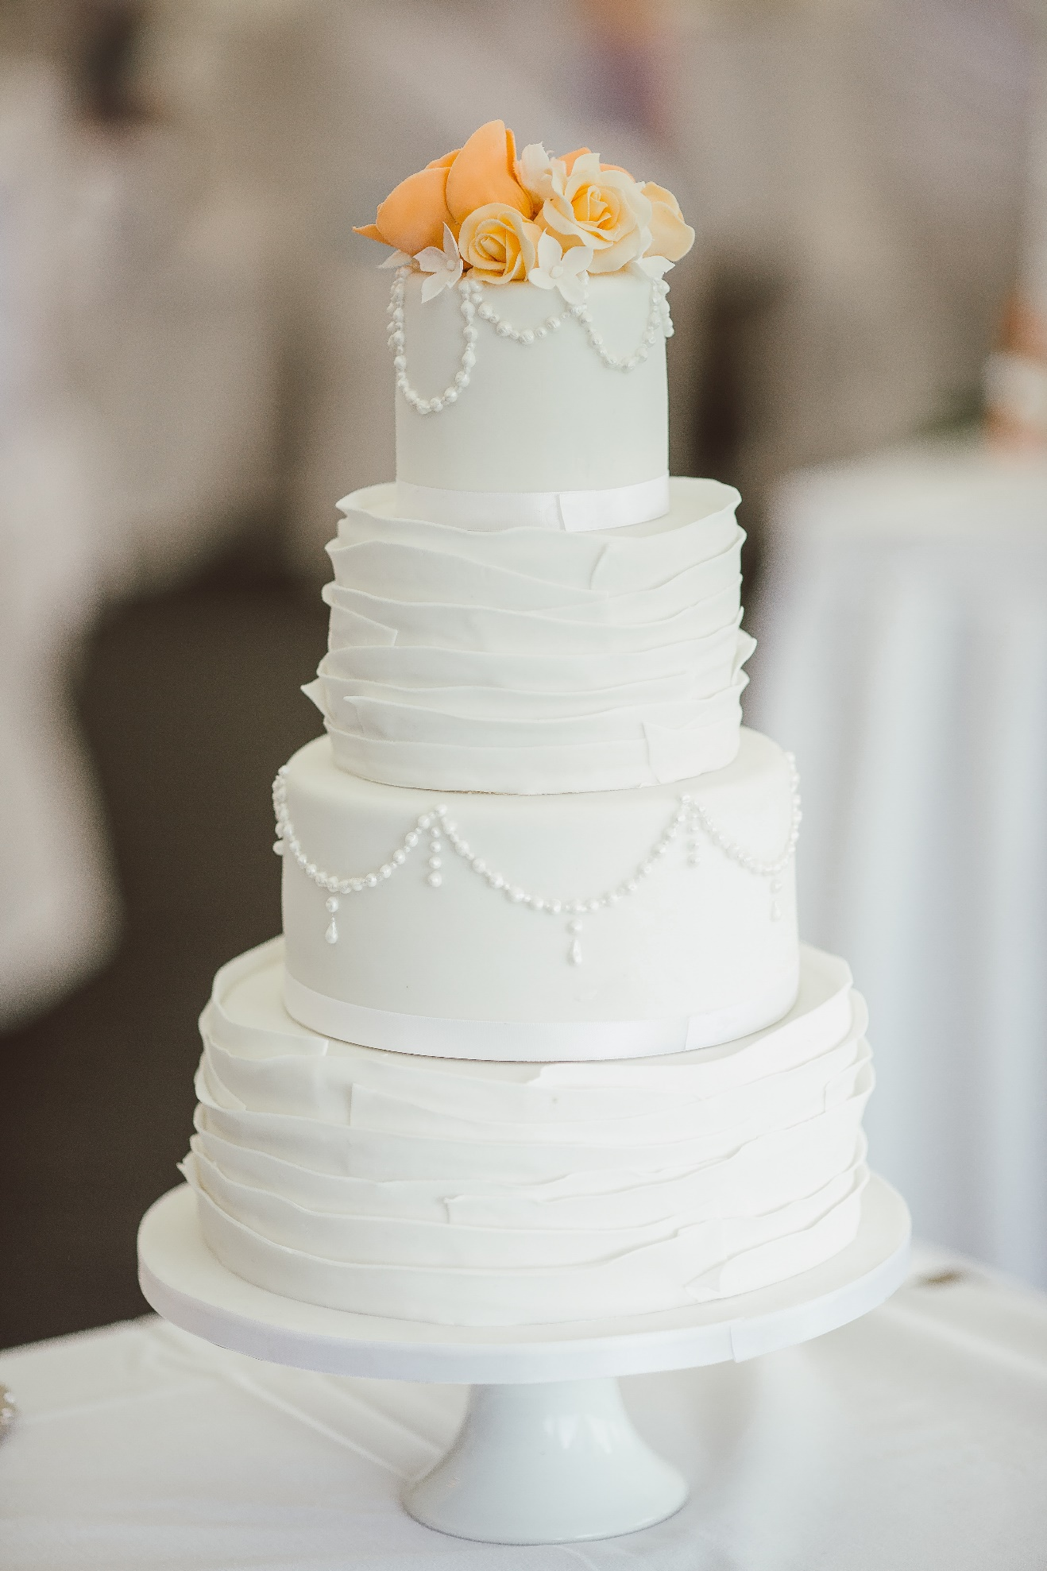

**SITE & VENUE CONDITIONS**

-- The Cake reserves the right to refuse set up of a cake in any location that is not properly air conditioned or weather proofed or on any cake plateau or stand that does not appear sturdy enough to hold the weight of our cakes. All efforts will be made to work with venue staff to find placement better suited for your cake to make sure it looks beautiful on your arrival.  
-- Cake is heavy and requires a perfectly level and sturdy table and cake plateau/stand. The Cake is not responsible for any damage caused by tables or cake plateaus/stands that were unable to withstand the weight of our cakes or improperly installed, or installed at a lean.  
-- Tall cocktail tables are not suitable for tiered cakes over 2 tiers tall, and are not recommended, as someone will have to climb a ladder to both set up the cake, and again at the reception to disassemble and serve your cake.  
-- Please be aware that 5 tiered or larger cakes on a standard height table may require a step stool or step ladder to disassemble and serve.



**RIGHTS & WAIVERS**

-- The Cake reserves the right to take photos of the product for display or promotion without the customer's consent.  
-- The Cake is not responsible for any damage to the cake after delivery/set up is complete. Cakes are heavy and require a climate controlled environment (at or below 75 degrees).   
-- If flowers are provided by an outside source, the arrangement of the flowers is included in the delivery fee. It is acknowledged by The Cake and the customer that fresh flowers are not a food product. They may contain pesticides, dirt, insects and other contaminants.   
-- If the customer elects to pick up the cake, the customer is responsible for the cake as soon as it leaves The Cake's premises. Upon visual inspection of cake and its departure from the premises, the customer approves the cake's visual appearance and waives any rights to a refund based on the style, design or visual appearance of the cake.   
-- The product may contain or come into contact with milk, wheat, nuts, soy and other allergens. The customer is responsible for notifying the guests. The Cake is not responsible for any adverse effects of allergic reactions.  
-- Upon the event of a natural disaster, accident or other situation outside of The Cake's control, this contract may be voided.  
-- The Cake will endeavor to perform its services in a professional manner and provide the best customer experience possible. In the event that our products or services do not meet our high standards, or the client is dissatisfied, we may--at our discretion--provide the amount paid for those products and services in the form of store credit. The Cake's total liability is hereby limited to amounts paid to The Cake for its goods and services. The Cake will not be liable for any special, incidental, punitive, or consequential damages, whether foreseen or unforeseen, regardless of whether liability is based on breach of contract, breach of express or implied warranty, negligence, strict liability, tort, or otherwise.   
-- Only items, actions and dessert details explicitly listed in the invoice are guaranteed by The Cake.



**EQUIPMENT RENTAL**

All equipment rental prices include a rental fee and a deposit. If the rented items are returned to The Cake within 3 days, the deposit will be returned to the customer electronically If the item is not returned within 3 days, the customer forfeits the deposit. If shipping the items back to The Cake, the customer will have 5 business days and must provide a shipping tracking number via email when shipped.

**CANCELLATIONS**

• Any cancellations must be made 72 hours in advance in writing and will result in a Store Credit ONLY.​